Name : Parthib Kumar Das , Enrollment No: 12023052002018 , CSE , Roll No: 18

Institute of Engineering & Management, Kolkata

Email ID: PARTHIBKUMAR.DAS2023@iem.edu.in

dasparthib111@gmail.com

Video Demonstration Link :

https://www.loom.com/share/8d5cbc9d342648b9b790a8c2944b7147
Github Repository Link :
https://github.com/Parthibkumardas/selenium_capstone-Parthib_Kumar_Das-

Capstone Assignment 2: Selenium Python Framework Development (Unittest + PyTest + POM)
Objective :
Design and develop a robust Selenium Python Automation Framework using:
- Unittest
- PyTest
- Page Object Model (POM)
- Utility Classes
- Configuration Management
- Test Data Handling (CSV)
- Screenshots on Failure
- HTML Reporting
Project Scenario
Automate the Login and Product Search functionality of an E-Commerce application using a scalable framework.
Suggested Application:
- https://tutorialsninja.com/demo/
- https://automationexercise.com/

Tools, Software, and Concepts Used
- Programming Language: Python
- Automation Tool: Selenium WebDriver
- Testing Frameworks: Unittest, PyTest
- Design Pattern: Page Object Model (POM)
- Browser: Google Chrome
- Driver Management: WebDriver Manager
- Test Data: CSV files
- Configuration: Configuration file (config.ini)
- Reporting: PyTest HTML Report
- Utilities: Screenshot capture, explicit waits, reusable utility functions
- Concepts: Automation Framework, POM, Test Data Handling, Configuration Management, Assertions, Exception Handling, Modular Testing

Source Code / Implementation
The framework was implemented using a modular folder structure:
SeleniumFramework/
│
├── config/
│ └── config.ini
│
├── testdata/
│ └── login_data.csv
│
├── pages/
│ ├── login_page.py
│ └── search_page.py
│
├── utilities/
│ ├── csv_reader.py
│ └── screenshot.py
│
├── tests/
│ ├── test_login.py
│ └── test_search.py
│
├── conftest.py
└── pytest.ini
Source Code :
create_test_user.py
import argparse
from pages.register_page import RegisterPage
from utils.csv_reader import get_test_data
from utils.driver_factory import DriverFactory
def main():
parser = argparse.ArgumentParser()
parser.add_argument("--headless", action="store_true")
args = parser.parse_args()
user = next(row for row in get_test_data("login_data") if row["expected_result"] == "success")
driver = DriverFactory.get_driver(headless=True if args.headless else None)
try:
page = RegisterPage(driver).open()
page.register("Capstone", "Tester", user["email"], "9999999999", user["password"])
if page.is_registration_successful():
print(f"Account created for {user['email']}")
else:
print(f"Registration did not succeed: {page.get_error_message()}")
print("If the e-mail is already registered, either it is yours already or pick a new "
"unique e-mail in testdata/login_data.csv and run this script again.")
finally:
driver.quit()
if __name__ == "__main__":
main()
Requirements.txt
selenium>=4.15.0
pytest>=7.4.0
pytest-html>=4.1.0
Run_unittest.py
import argparse
import os
import sys
import unittest
from datetime import datetime
from utils.config_reader import ROOT_DIR, ConfigReader
from utils.html_reporter import HtmlTestResult, write_html_report
def main():
parser = argparse.ArgumentParser(description="Run unittest suite with HTML report")
parser.add_argument("--browser", help="chrome | firefox | edge")
parser.add_argument("--headless", action="store_true")
parser.add_argument("--pattern", default="test_*.py")
args = parser.parse_args()
# ConfigReader gives environment variables priority over config.ini
if args.browser:
os.environ["BROWSER"] = args.browser
if args.headless:
os.environ["HEADLESS"] = "true"
start_dir = ROOT_DIR / "tests" / "unittest_tests"
suite = unittest.defaultTestLoader.discover(
str(start_dir), pattern=args.pattern, top_level_dir=str(ROOT_DIR))
result = unittest.TextTestRunner(verbosity=2, resultclass=HtmlTestResult).run(suite)
report = ConfigReader.get_path("reports") / f"unittest_report_{datetime.now():%Y%m%d_%H%M%S}.html"
write_html_report(result.records, report, "Selenium Capstone - Unittest Report")
print(f"\nHTML report: {report}")
return 0 if result.wasSuccessful() else 1
if __name__ == "__main__":
sys.exit(main())
test_login_unittest.py :
from pages.account_page import AccountPage
from pages.home_page import HomePage
from tests.unittest_tests.base_test import BaseTest
from utils.csv_reader import get_test_data
LOGIN_DATA = get_test_data("login_data")
VALID_USER = next(row for row in LOGIN_DATA if row["expected_result"] == "success")
class LoginUnittest(BaseTest):
def test_login_page_loads_from_home_page(self):
login_page = HomePage(self.driver).go_to_login_page()
self.assertTrue(login_page.is_loaded(), "Login form was not displayed")
self.assertIn("Account Login", self.driver.title)
def test_logout_after_successful_login(self):
login_page = HomePage(self.driver).go_to_login_page()
login_page.login(VALID_USER["email"], VALID_USER["password"])
account_page = AccountPage(self.driver)
self.assertTrue(account_page.is_loaded())
account_page.logout()
self.assertTrue(account_page.is_logout_successful())
def _build_login_test(row):
def test(self):
login_page = HomePage(self.driver).go_to_login_page()
login_page.login(row["email"], row["password"])
if row["expected_result"] == "success":
self.assertTrue(AccountPage(self.driver).is_loaded(),
f"Valid login failed for {row['email']}. Run create_test_user.py first.")
else:
self.assertIn(row["expected_message"], login_page.get_error_message())
return test
# One real test method per CSV row, so each row gets its own browser, result and screenshot.
for _row in LOGIN_DATA:
setattr(LoginUnittest, f"test_{_row['test_id'].lower()}_data_driven", _build_login_test(_row))
test_search_pytest.py :
import pytest
from pages.home_page import HomePage
from utils.csv_reader import get_test_data
SEARCH_DATA = get_test_data("search_data")
@pytest.mark.regression
@pytest.mark.parametrize("row", SEARCH_DATA, ids=[row["test_id"] for row in SEARCH_DATA])
def test_search_data_driven(driver, row):
results = HomePage(driver).search_for(row["search_term"])
if row["expected_result"] == "found":
names = results.get_product_names()
assert len(names) >= int(row["min_count"]), f"Expected >= {row['min_count']} products, got {names}"
assert any(row["expected_product"].lower() in name.lower() for name in names), (
f"'{row['expected_product']}' not found in {names}"
)
else:
assert results.has_no_results(), "Expected the 'no product' message"
assert "no product that matches" in results.get_no_result_message()
@pytest.mark.smoke
def test_search_results_heading_contains_search_term(driver):
results = HomePage(driver).search_for("iphone")
assert "iphone" in results.get_heading().lower()
account_page.py :
from selenium.webdriver.common.by import By
from pages.base_page import BasePage
class AccountPage(BasePage):
HEADING = (By.XPATH, "//div[@id='content']//h2[normalize-space()='My Account']")
# The right sidebar is an <aside id="column-right">, so the locator must not assume a <div>
LOGOUT_LINK = (By.XPATH, "//*[@id='column-right']//a[normalize-space()='Logout']")
LOGOUT_HEADING = (By.XPATH, "//div[@id='content']//h1[normalize-space()='Account Logout']")
def is_loaded(self):
return self.is_displayed(self.HEADING)
def logout(self):
self.click(self.LOGOUT_LINK)
def is_logout_successful(self):
return self.is_displayed(self.LOGOUT_HEADING)
home_page.py :
from selenium.webdriver.common.by import By
from pages.base_page import BasePage
from pages.login_page import LoginPage
from pages.search_results_page import SearchResultsPage
class HomePage(BasePage):
SEARCH_INPUT = (By.CSS_SELECTOR, "#search input[name='search']")
SEARCH_BUTTON = (By.CSS_SELECTOR, "#search button")
MY_ACCOUNT_MENU = (By.XPATH, "//a[@title='My Account']")
LOGIN_LINK = (By.XPATH, "//ul[contains(@class,'dropdown-menu')]//a[normalize-space()='Login']")
def open(self):
self.open_path("")
return self
def search_for(self, term):
self.type_text(self.SEARCH_INPUT, term)
self.click(self.SEARCH_BUTTON)
return SearchResultsPage(self.driver)
def go_to_login_page(self):
self.click(self.MY_ACCOUNT_MENU)
self.click(self.LOGIN_LINK)
return LoginPage(self.driver)
login_page.py :
from selenium.webdriver.common.by import By
from pages.base_page import BasePage
class LoginPage(BasePage):
PATH = "index.php?route=account/login"
RETURNING_CUSTOMER_HEADING = (By.XPATH, "//h2[normalize-space()='Returning Customer']")
EMAIL_INPUT = (By.ID, "input-email")
PASSWORD_INPUT = (By.ID, "input-password")
LOGIN_BUTTON = (By.CSS_SELECTOR, "input[value='Login']")
ERROR_ALERT = (By.CSS_SELECTOR, "div.alert-danger")
def open(self):
self.open_path(self.PATH)
return self
def is_loaded(self):
return self.is_displayed(self.RETURNING_CUSTOMER_HEADING) and self.is_displayed(self.LOGIN_BUTTON)
def login(self, email, password):
self.type_text(self.EMAIL_INPUT, email)
self.type_text(self.PASSWORD_INPUT, password)
self.click(self.LOGIN_BUTTON)
def get_error_message(self):
return self.get_text(self.ERROR_ALERT)
register_page.py :
from selenium.webdriver.common.by import By
from pages.base_page import BasePage
class RegisterPage(BasePage):
"""Used only by create_test_user.py to prepare the account for the valid-login test."""
PATH = "index.php?route=account/register"
FIRST_NAME = (By.ID, "input-firstname")
LAST_NAME = (By.ID, "input-lastname")
EMAIL = (By.ID, "input-email")
TELEPHONE = (By.ID, "input-telephone")
PASSWORD = (By.ID, "input-password")
CONFIRM = (By.ID, "input-confirm")
AGREE = (By.NAME, "agree")
CONTINUE = (By.CSS_SELECTOR, "input[value='Continue']")
SUCCESS_HEADING = (By.XPATH, "//div[@id='content']/h1[contains(.,'Your Account Has Been Created')]")
ERROR_ALERT = (By.CSS_SELECTOR, "div.alert-danger")
def open(self):
self.open_path(self.PATH)
return self
def register(self, first_name, last_name, email, telephone, password):
self.type_text(self.FIRST_NAME, first_name)
self.type_text(self.LAST_NAME, last_name)
self.type_text(self.EMAIL, email)
self.type_text(self.TELEPHONE, telephone)
self.type_text(self.PASSWORD, password)
self.type_text(self.CONFIRM, password)
self.click(self.AGREE)
self.click(self.CONTINUE)
def is_registration_successful(self):
return self.is_displayed(self.SUCCESS_HEADING)
def get_error_message(self):
return self.get_text(self.ERROR_ALERT)
search_results _page.py :
from selenium.webdriver.common.by import By
from selenium.webdriver.support import expected_conditions as EC
from pages.base_page import BasePage
class SearchResultsPage(BasePage):
HEADING = (By.XPATH, "//div[@id='content']/h1[starts-with(normalize-space(),'Search')]")
PRODUCT_NAMES = (By.CSS_SELECTOR, "#content .product-layout .caption h4 a")
NO_RESULT_MESSAGE = (
By.XPATH, "//div[@id='content']//p[contains(normalize-space(),'no product that matches')]")
def wait_for_results(self):
self.wait.until(
EC.any_of(
EC.presence_of_element_located(self.PRODUCT_NAMES),
EC.presence_of_element_located(self.NO_RESULT_MESSAGE),))
def get_heading(self):
return self.get_text(self.HEADING)
def get_product_names(self):
self.wait_for_results()
return [element.text.strip() for element in self.driver.find_elements(*self.PRODUCT_NAMES)]
def has_no_results(self):
self.wait_for_results()
return bool(self.driver.find_elements(*self.NO_RESULT_MESSAGE))
def get_no_result_message(self):
return self.get_text(self.NO_RESULT_MESSAGE)
I also use 2 test_datasets 1. Test_login.csv 2. Test_search.csv
Output with clearly labelled screenshots :
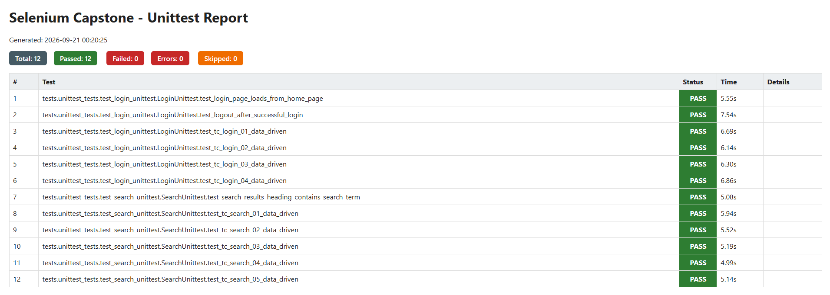
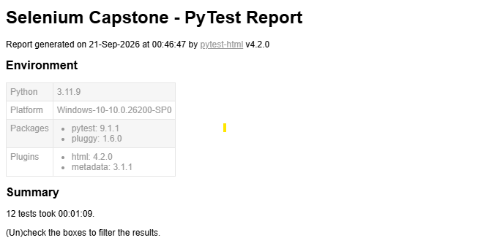
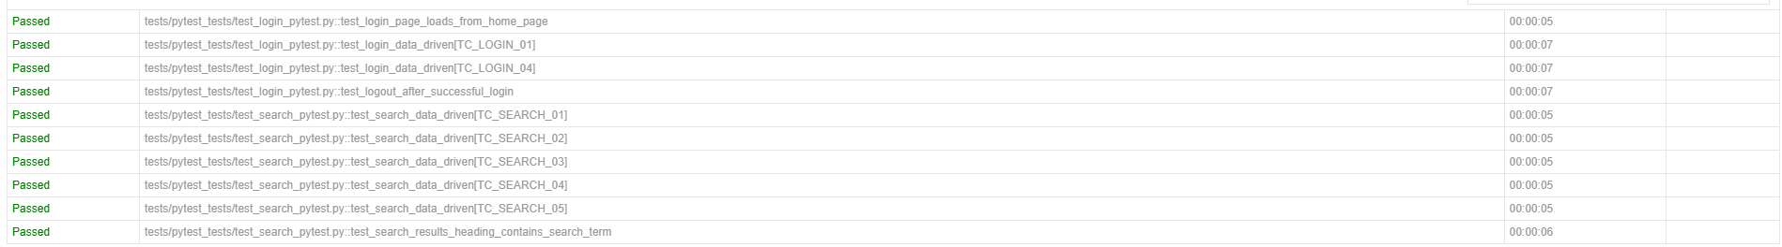
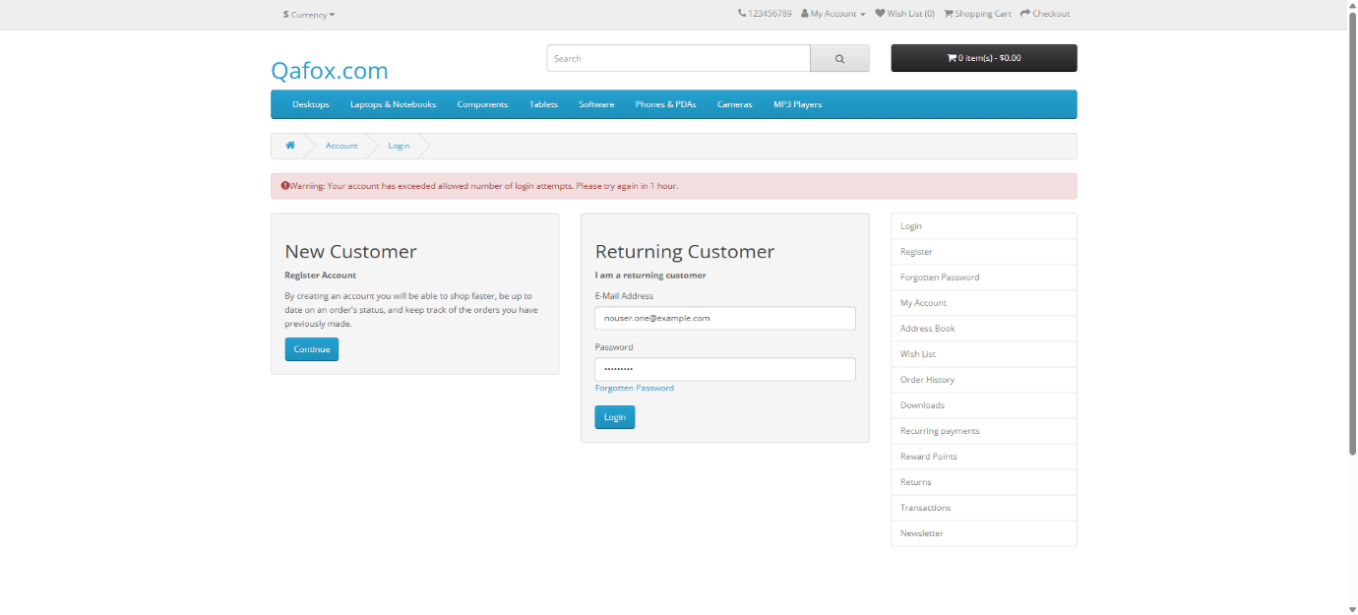

Result:
The Selenium Python framework successfully automated the Login and Product Search functionalities of the selected e-commerce application.
The framework was able to:
- Launch the browser.
- Open the application.
- Read test data from CSV.
- Perform login operations.
- Search for products.
- Validate expected results.
- Capture screenshots when tests failed.
- Generate an HTML test execution report.

Observation:
- POM made the framework more organized and reusable.
- PyTest simplified test execution and reporting.
- Unittest provided a standard testing structure.
- CSV-based test data allowed multiple test cases to be executed without changing the test code.
- Configuration management made application settings easier to maintain.
- Screenshots helped identify the cause of failed test cases.
- HTML reports provided a clear summary of test execution.

Conclusion:
The project successfully demonstrated the development of a scalable Selenium Python automation framework using Unittest, PyTest, Page Object Model, utility classes, configuration management, CSV test data, screenshots, and HTML reporting. The framework improves code reusability, maintainability, and the efficiency of automated testing for e-commerce applications.

